

*OULTC Alumni*

*Newsletter Hilary 2019*

Hello everyone and I hope you are all well!

It’s been a while since the previous newsletter and a lot has happened in the club since then. With the 2018/19 season now in full swing, I’d firstly like to thank Sam Keat for all his great work last year and introduce myself, Casper, as the alumni officer for the coming year. We always enjoy hearing from our alumni, so if you ever have any questions or suggestions for ways to maintain the club’s network beyond Oxford then please don’t hesitate to contact me or a member of the committee, headed by our excellent president Katie Baston.

Anyway that’s enough about me and please read on for the highlights of the season so far, developments within OULTC, and upcoming events.

Best wishes to all,

Casper

OULTC Alumni Officer

Preseason

This academic year the improvements within OULTC started before Michaelmas term had even started. Rather than spending the final week or so of the summer break on the beach in Marbella or revising for collections, both Blues teams, as well as W2, were put through their paces in an intensive preseason schedule, something which had been lacking in recent years. This involved everything from frequent hitting sessions, to nutrition classes and fitness training. Not only was it a chance for returning players to get back into a rhythm, but it also provided an opportunity for new OULTC members to showcase their talent. Early BUCS matches seem to suggest this has fostered improved results on the court and is something that will hopefully be expanded to more teams in coming years.

BUCS Matches

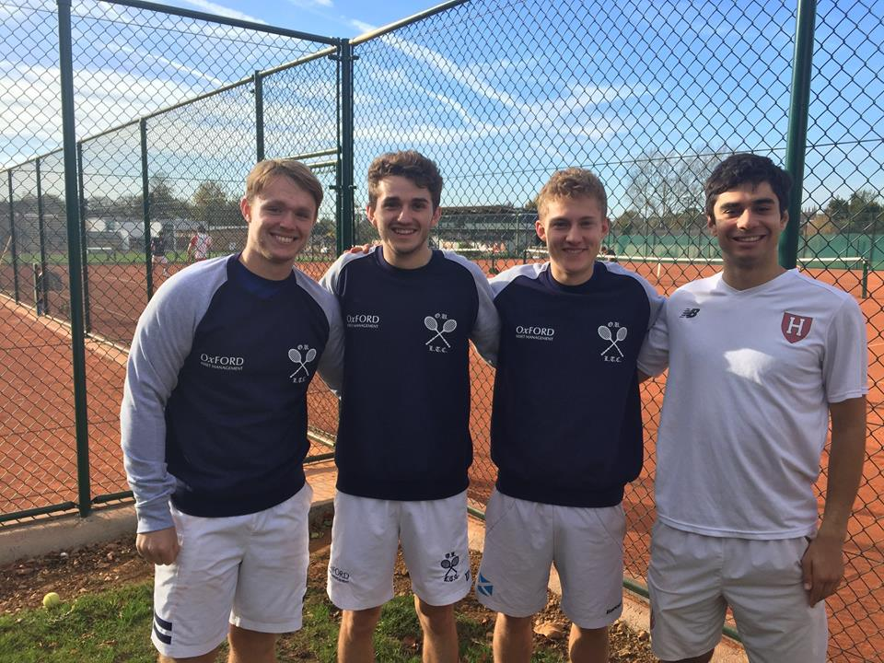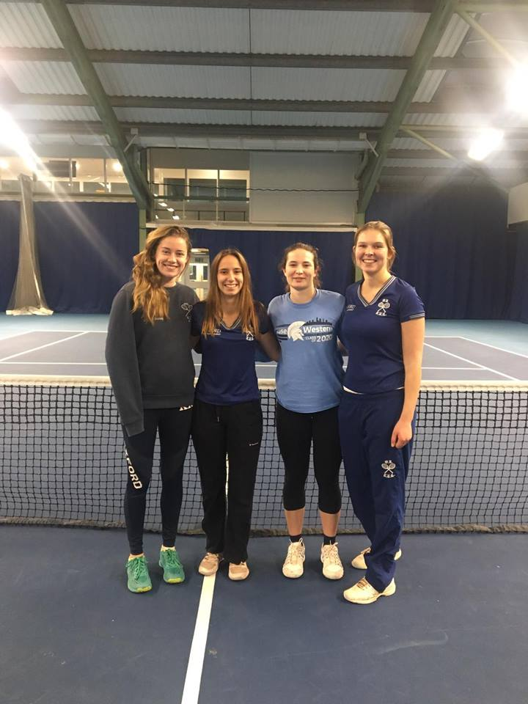Following the first term of BUCS matches, strong performances have been observed across the board with the majority of teams either pushing for promotion or sitting comfortably in mid-table positions. A major development within OULTC this academic year has been the introduction of both the men’s and women’s 4th teams to the BUCS leagues, allowing more players to get involved in regular match play as well as emphasising a squad depth unparalleled by most universities in the country. Both Blues teams currently sit in mid-table in their respective leagues, and with some strong performances in the coming term can certainly look to push for success in league and cup come the end of the season. Lead by captain Oliver Nunn, special mentions in M1 should go to the Scottish duo of Cameron Bowie and Ross Martin, who have both featured in all the team’s fixtures and put in doubles performances the Murray brothers would have been proud of. Meanwhile Nanami Yamaguchi has led by example in W1, winning 12 of 14 matches including vital victories in the team’s impressive defeat of 2nd placed Bristol. The 2nd teams have had the most impressive set of results thus far, both sitting second in their divisions and looking to muster a title challenge, with M2 still on for an unbeaten season. The 3rd and 4th teams have had a mixed bag of results, all currently in fierce battles for positions in mid-table in their respective leagues, but strong second halves of the season should ensure that their targets are achieved. Best of luck to all teams in Hilary Term!

Upcoming Events

Preparations for this year’s Alumni Dinner are already well underway, and following the success of last year’s event we look forward to seeing lots of you there! Due to some unforeseen issues, the dinner will be held at a slightly later date than last year, in early May. The exact details are still to be confirmed, but keep our eyes peeled for invites to be sent out in due course. We look forward to seeing many of you there!

We are also happy to announce that the Blues Varsity match against Cambridge will return to the stunning Moor Park Club for a second year. However, there are exciting changes in the pipeline for this year’s event, with the aim to turn it into one of the quintessential pre-Wimbledon weekend events, with a considerable focus on the alumni experience. Current ideas in the pipeline include a champagne reception, a mixed players and alumni dinner, courts for alumni to hit on during the weekend, drinks deals, local food vendors, and of course strawberries and cream. Further details will be sent out in due course so keep up to date with our Facebook event: <https://www.facebook.com/events/359550367931919/>

In addition, please see the following list for an overview of other upcoming OULTC events which may be of interest:

* Women’s Blues vs The All England Club – 2nd March
* Men’s Blues vs The All England Club – 3rd March
* Blues vs St Gallen University – 1st and 2nd June in Oxford
* Blues Varsity – 29th and 30th June at Moor Park
* 2s/3s/4s/5s Varsities – 29th and 30th June in Cambridge

Other News

A major development within the club this term has been the opening of our four new clay courts on Iffley Road. They play fantastically and are certainly a huge improvement from the old hard courts. A massive thank you should go to everyone who been involved in making this development possible, and a special mention to our previous Facilities Officer, Kirill, who played a central role in the project. In the near future the club is also looking to renovate the clubhouse to complete these redevelopments, which will be a welcome improvement to the Iffley Road venue. Planning for this is currently in progress, and should you wish to find out more information or support this project then do not hesitate to get in touch with the club.

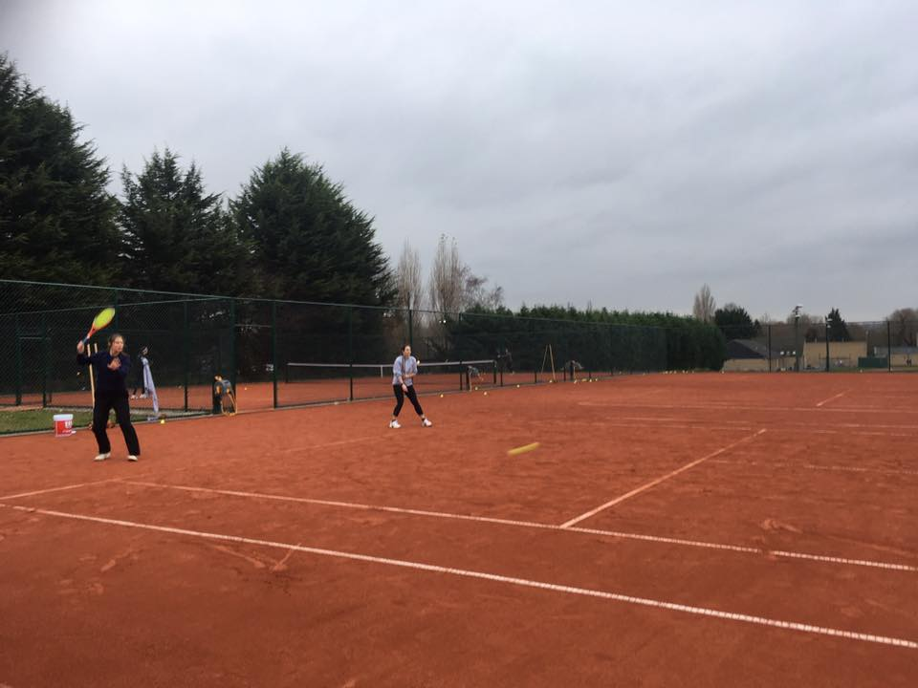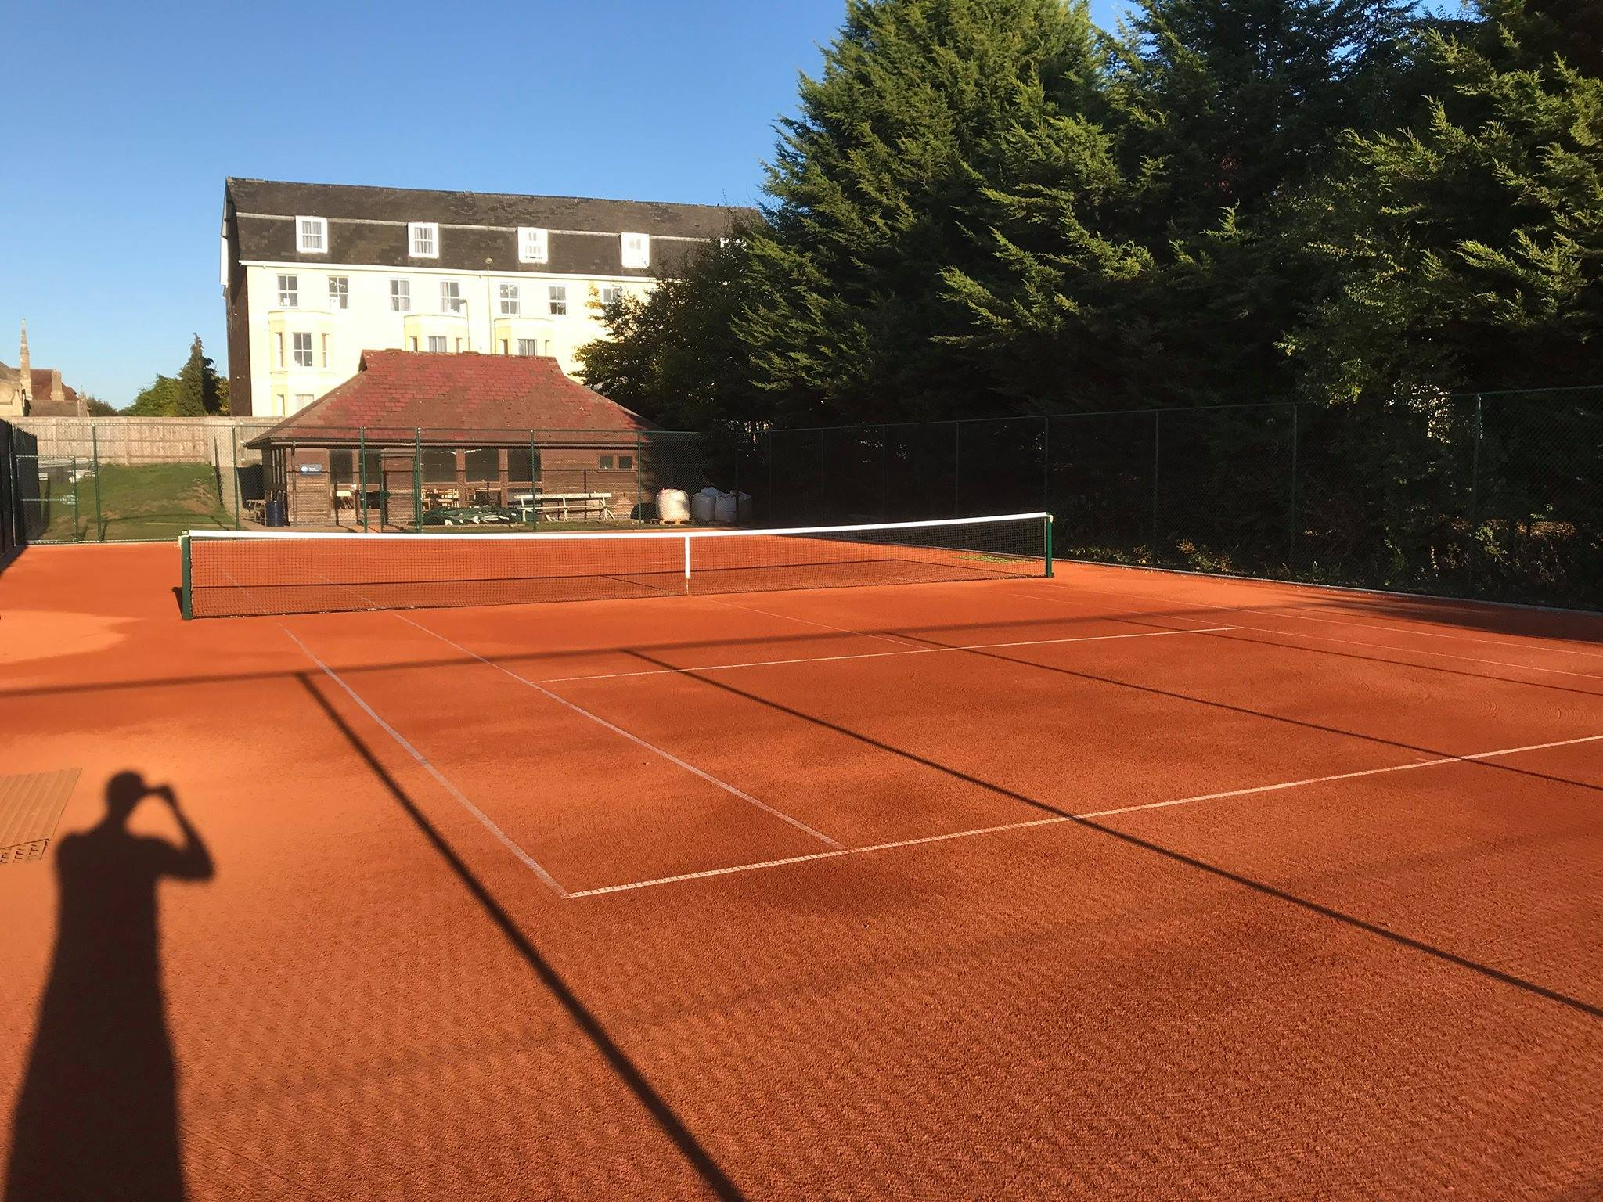

We are also looking forward to the upcoming tours, which will take place in the Easter vacation and should be the perfect way to begin preparations for the 2019 Varsity matches. The Blues are set to travel to Miami, whilst the 2nd and 3rd teams will be going to Vale de Lobo in the Algarve.

Contact

We have recently set up a couple of new Facebook groups aimed at helping alumni keep in touch with OULTC and its community of past members. To find the group for all alumni you should be able to join the page called ‘OULTC Alumni’, whilst previous Blues players are encouraged to join both this group and the one called ‘OULTC Old Blues’.

If you have any questions, suggestions or would like to find out more about OULTC and its alumni programme, please get in touch by emailing [oultcalumni@gmail.com](mailto:oultcalumni@gmail.com).

Also make sure to follow the official Oxford University Lawn Tennis Club Facebook page for regular updates on matches and events, as well as our Instagram (@oultc1880). For general information please visit our new and improved website at [www.oultc.org](http://www.oultc.org).